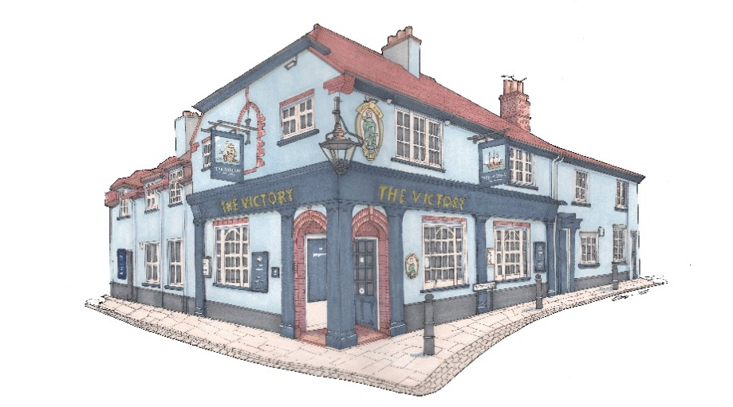

Small plates £10
Brown shrimp & chilli fishcakes, sweet chilli (GF)
½ pint prawns, lemon mayo, toast *
Deep fried squid, saffron mayo
French onion soup, cheese crouton (GF)
Arancini, dolcelatte & tomato salsa (GF) (V)
Corn-fed chicken, apricot & herb terrine, toast, chutney
Smoked mackerel pate, cornichons, toast
King prawns, garlic & chilli oil (GF)
Smoked salmon, pickled cabbage, sesame, soy dressing (GF)
New Zealand green lip mussels, garlic butter, parmesan, toast *
Sweet chilli chicken wings (GF)
Deep fried whitebait, tartare sauce
BBQ ribs (GF)
Honey & herb Chipolatas
Paprika smoked chicken goujons, lemon mayo (GF)
Cod goujons, tartare sauce (GF)
Sauté wild mushroom, toast (V)

ANY 3 FOR £25

Signature Dishes
Chargrilled ribeye steak, sauté potatoes, wild mushrooms, tomatoes & garlic butter (GF) £30
Roasted loin of cod, samphire bouillabaisse, Rouille (GF) £28
Herb roast rack of lamb, boulangère pots, carrot & swede puree, rosemary jus (GF) £28
Goats cheese & beetroot tart, Mediterranean veg & pesto, rocket (V) £19
Please advise your server of any food allergies or intolerances.
* Gluten free option available *

